The Effect of Human Capital Loss during COVID-19 on Youth Labor Market Outcomes in Guatemala
Author: Fernando José Sáenz Aguilar
Advisor: Rodolfo José Mérida Ochoa
JEL Classification: C31, E24, I26, I28, J24.

Abstract:
It has been five years since the COVID-19 pandemic produced an enormous shock worldwide. This represented not only a public health crisis but also the generation of social and economic problems. Youth were among the most vulnerable social groups during this period, experiencing setbacks in education due to school closures and the difficult transition to distance learning, often without the resources needed to access it properly. This paper aims to determine whether there was a negative impact on the labor market outcomes of the cohort that completed their last year of high school in Guatemala during the pandemic. To achieve such, this study applies modern microeconometric techniques to derive rigorous evidence and establish causality, specifically using a DiD approach. The results show a 50% decrease in the probability of occupation, signaling a delay in access to the labor market. Besides, the study also finds patterns suggesting lower earnings, which highlights the need for further research to inform policy development.
Keywords: COVID-19 pandemic, Guatemala, human capital, education, youth, labor market, differences-in-differences.

Resumen:
Han transcurrido cinco años desde que la pandemia de COVID-19 generó un shock inesperado a nivel mundial. Este no solo implicó una crisis de salud pública, sino que sus efectos trascendieron a problemas económicos y sociales. Los jóvenes fueron uno de los grupos más vulnerables durante este periodo, especialmente por los retrasos educativos ocasionados por el cierre de escuelas y la compleja transición hacia la educación a distancia, que en muchos casos ocurrió sin los recursos necesarios para recibirla adecuadamente. La presente investigación busca determinar si existió un impacto negativo en los resultados laborales de la cohorte que cursó su último año de diversificado en Guatemala durante la pandemia. Para ello, se emplearon técnicas modernas de microeconometría aplicada que permiten obtener evidencia rigurosa y establecer causalidad; en específico, se utilizó un modelo DiD. Los resultados muestran una disminución del 50% en la probabilidad de ocupación, lo cual señala un retraso en la entrada al mercado laboral. Asimismo, se identifican patrones que sugieren menores ingresos, subrayando la necesidad de generar más investigación al respecto para orientar el diseño de políticas públicas adecuadas a contrarrestar los impactos y minimizar brechas entre cohortes.
Palabras clave: Pandemia de COVID-19, Guatemala, capital humano, educación, jóvenes, mercado laboral, diferencias-en-diferencias.
- Introduction
Education is an important topic for all people and in all societies, allowing children to achieve positive impacts on their social relationships, political participation, self-esteem, health, and understanding of the world. But its benefits are not limited only to societal dimensions; indeed, the connection between education and economic outcomes has been of strong interest to economists, forming the foundation of Human Capital Theory.
Mincer (1958) argued that the oldest theory in the field might have been the one relating the distribution of income to the distribution of “ability” among the population. Perhaps, this view on the “innate ability” of people determining their potential future earnings was still too abstract and somewhat ambiguous, as it implies that how well you are going to do in life is not under personal control but rather a matter of chance, depending on whether you were born more or less able. Becker (1962) added another perspective, indicating that all activities dedicated to introducing knowledge and skills in people are ways to gain human capital. Ben-Porath (1967) later backed this, arguing that human capital cannot simply be acquired, but that the individual must actively participate in creating it. Examples they provided of ways of gaining human capital include schooling, job training, medical care, and immunization.
The models of economic growth developed from the mid-twentieth century and onward, under the lead of Solow, described some of the stylized facts of economic growth, including diminishing returns and the existence of a steady state that the economy would eventually reach. However, as Lucas (1988) pointed out, they failed to explain the differences in income across countries. Embedded in this question, he worked on an “Economic Development Theory,” whose principal argument was that not only physical capital accumulation was necessary to grow, but also human capital. He proposed that human capital impacted economic output by improving labor force productivity and also by a spillover effect that increased others’ human capital. However, the international movement of people with high human capital from poor to rich countries was a key factor behind persistent inequalities.
After his proposal, many others supported the idea of human capital as a determinant of economic growth and developed their own approaches. Romer (1990) claimed that human capital increases economic growth because it accelerates technological progress, as more educated people can conduct better research. Furthermore, Barro (1991) and later Mankiw, Romer, and Weil (1992) emphasized that higher human capital leads to lower fertility rates and higher saving rates.
Following this logic and looking at the data for Guatemala, one can find striking correlations between education and economic variables. Panel A in Figure 1 compares years of schooling with personal labor income, while Panel B presents the school enrollment rate against the GDP per capita of all the municipalities in the country.

Figure 1. Correlation between education and income in Guatemala
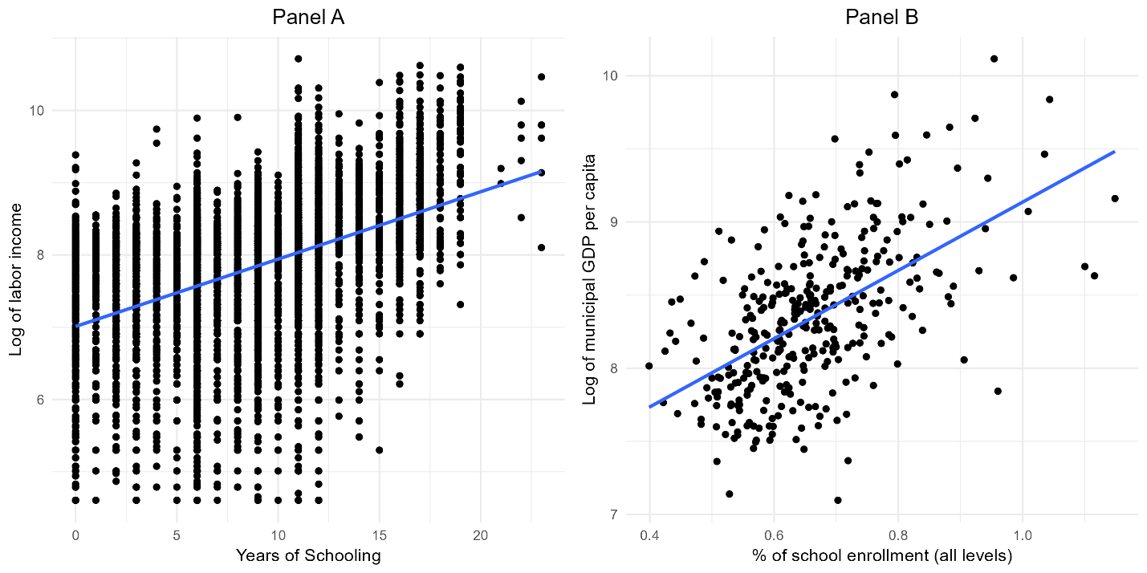
Source: Author’s work, using data from the National Employment and Income Survey 2024 (INE, 2025) and the Local Competitiveness Index 2024 (FUNDESA, 2025). Labor income is measured as the sum of wages, overtime compensation, commissions, travel allowances, and bonuses earned from the primary occupation.

Table 1. Correlation between education and income in Guatemala
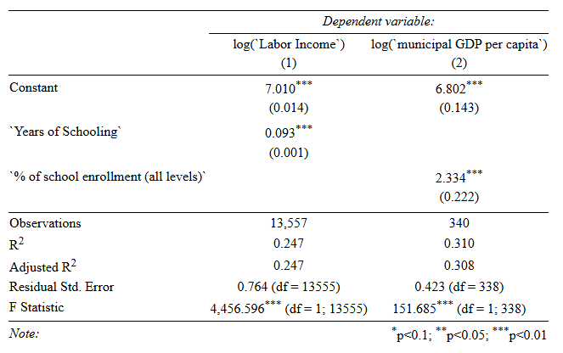
Source: Author’s calculations, using data from the National Employment and Income Survey 2024 (INE, 2025) and the Local Competitiveness Index 2024 (FUNDESA, 2025). Labor income is measured as in the graph above. Table created using the Stargazer R package (Hlavac, 2022).
Both plots showcase a positive association: each year of schooling is associated with 9.3% higher labor income on average, and a one-percentage-point increase in enrollment rate correlates with a 2.33% increase in the municipality's GDP per capita. According to Table 1, the two education variables can explain between 24% and 31% of income variance.
Moving to aggregated data, Figure 2 depicts the logarithmic growth rates of High School enrollment and GDP for the period between 2001 and 2024, excluding 2013 and 2014 due to missing administrative data from the Ministry of Education for those years. At first, the relationship between the two variables is not entirely clear, but some patterns can be observed over time. For example, the high school enrollment boost in 2004 coincides with higher GDP growth in 2006 and 2007. Similarly, the decline in enrollment in 2010 aligns with a GDP slowdown in 2012, and an upward trend in enrollment in 2016 seems to accompany an increase in GDP in 2017.
Computing the OLS estimates in Table 2, it is possible to see that GDP correlates positively with High School enrollment, but with a one-year lag. The goodness of fit is quite low, although this is understandable since economic growth is explained by multiple variables, as macroeconomic theory suggests (e.g., inflation, unemployment, savings, investment, etc.). Furthermore, the highest educational level attained by most people in Guatemala remains in elementary school. Hence, High School enrollment being able to explain around 15% of the variance is still an important observation, even if only descriptive.

Figure 2. National High School enrolment v. GDP growth 2001-2024
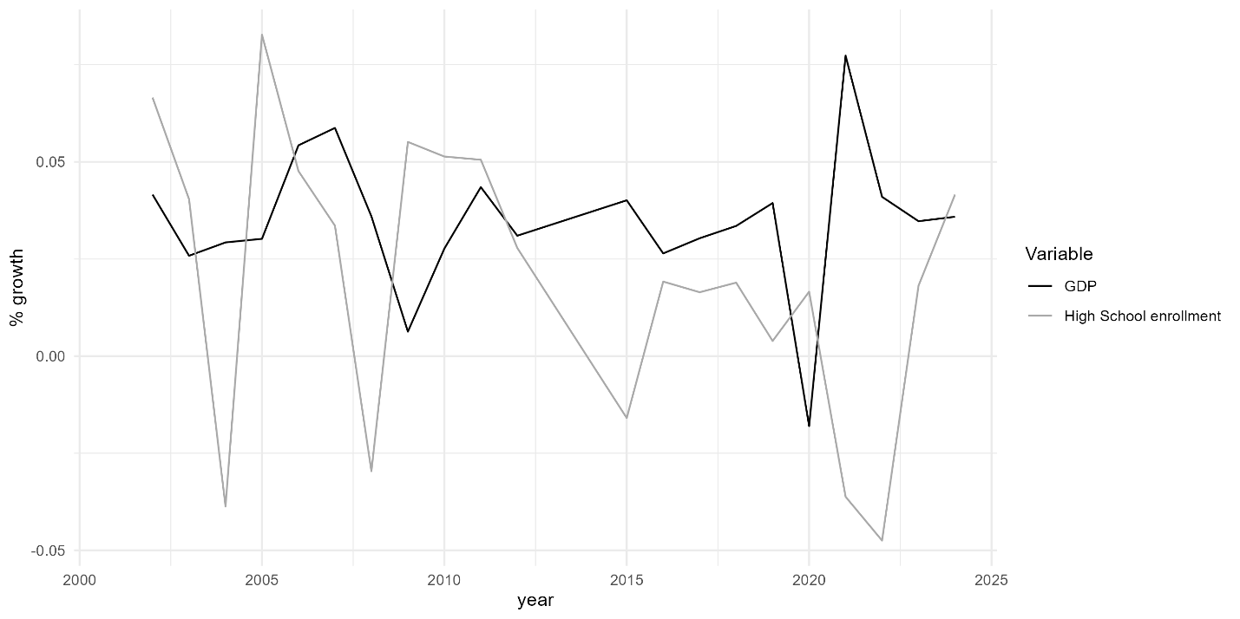
Source: Author’s work, using data from the Ministry of Education (MINEDUC, 2025) and the Bank of Guatemala (BANGUAT, 2025).

Table 2. Correlation between National High School enrolment and GDP growth
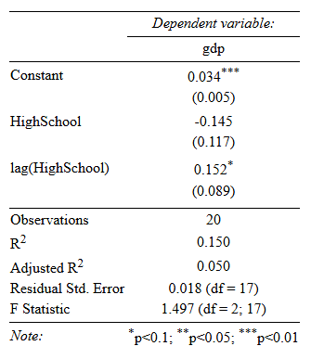
Source: Author’s calculations, using data from the Ministry of Education (MINEDUC, 2025) and the Bank of Guatemala (BANGUAT, 2025). Table created using the Stargazer R package (Hlavac, 2022).

Given that the pandemic represented an interruption in schooling, as the government required schools to close and adapt to distance teaching methods, and considering the limited access to the internet or technological devices to receive quality classes online, human capital could not develop as it would have had the pandemic not happened. Since both theory and descriptive data suggest a relationship between human capital formation in terms of education and economic outcomes, it is important to ask: Did the pandemic generate adverse impacts on youth income and labor market outcomes as a consequence of human capital loss? Moreover, were these transitory or did they persist over time?
This paper aims to address these questions and derive rigorous estimators, contributing with a novel application of modern causal inference techniques to measure the pandemic’s impact on youth labor market outcomes in Guatemala. The structure of the work is as follows: Section 2 presents a brief literature review on empirical evidence supporting the impact of education on earnings, the impact of the pandemic on education outcomes, and the dynamics of labor markets in the region during the health crisis. Section 3 presents the data used and the identification strategy for obtaining a causal estimation. Section 4 explores and discusses the results, and Section 5 offers the concluding remarks.
- Literature Review

  - Human Capital and Economic Growth: Empirical Evidence
There is a compelling paradox in the literature aiming to provide strong evidence of a relationship between education and economic outcomes. From the macro-perspective, several authors refuted the hypothesis by estimating panel data models using information from the decades of 1960 to 1985. For example, Benhabib and Spiegel (1994) point out that “human capital enters insignificantly in explaining per capita growth rates” when considered a direct input, showing relevance only through its impacts on technological innovation and the adoption of technology advancements from abroad. Later, Bils and Klenow (2000) indicate the relationship fails to show a robust effect in either case, and Pritchett (2001) showed that education contributed less than what is predicted by mathematical models.
Pritchett recognizes that these results might not indicate the absence of a relationship between education and economic growth, but attributes them to external factors that can undermine the impact of education. These include weak institutions that encourage high-skilled individuals to engage in unproductive or undesirable activities, such as corruption; the slow increase in demand for educated workers, creating imbalances in labor markets; and low-quality education that does not ensure individuals acquire the necessary skills to perform well in a job.
Other authors defend the existence of a positive relationship between education and economic growth and provide empirical support. Barro and Lee (1993) highlight that education data are difficult to harmonize across countries and, instead of relying solely on administrative records, construct their own dataset to show a positive relationship between GDP per capita, physical investment, and educational attainment. Similarly, Krueger and Lindahl (2000) argue that studies denying the link between education and growth often fail to properly account for measurement error in education data, leading to spurious results. After correcting for this, the relationship becomes clear. Zaman (2013) shows that analyzing the impact of human capital through accumulation and through fostering technology adoption separately yields insignificant results, but integrating both channels in a single model produces a strong relationship, highlighting misspecification in earlier studies.
In contrast to the ambiguous results at the macro-level, evidence at the micro-level is stronger and more directly causal. In that sense, one can remember the classic paper by Duflo (2001), where she evaluates a natural experiment of school construction in Indonesia using an instrumental variables approach, finding that each school built per 1,000 children increased average schooling by 0.12–0.19 years, and that each additional year of schooling raised income by 6.8–10.6%. More recently, Duflo, Dupas, and Kremer (2021) examined the long-term returns of education in Ghana, following scholarship recipients over 20 years, and found significant labor market gains, particularly for females.
Other pieces of evidence includes Ashenfelter & Krueger (1992), who compare identical twins with different educational levels and find that an additional year of schooling increases wages by 16%, and Chetty et al (2011), who analyze the STAR Project in the United States and conclude that one-percentile increase in kindergarten test scores leads to an approximate $132 increase in future wage earnings.
Finally, Arteaga (2018) evaluates the effect of a reform in a private university in Colombia that reduced the requirements for obtaining a degree. She found that the reform decreased wages of newer graduates by 13-16%. This result is particularly noteworthy, since most evidence examines the relationship between more education and higher income, but she demonstrates that the relationship can work the other way: a decrease in education can lead to a fall in earnings, which directly aligns with the focus of the research question asked in this study.

  - COVID-19 Pandemic and Human Capital
It is clear that the COVID-19 pandemic impacted schooling outcomes around the world; however, quantifying the magnitude of this impact is more challenging. In this sense, the World Bank (2021) warns that Latin America and the Caribbean could experience the second-largest absolute increase in learning poverty, estimating that countries in the region missed an average of 159 school days during 2020. This affected over 170 million students and led to a 15% increase in dropouts. Furthermore, they point out that 2 out of 3 children might not be able to understand age-appropriate texts, highlighting a lag in skills acquisition that can have long-term repercussions.
The World Food Program (2022) shares this concern and adds that “if actions are not taken to help increase their resilience and build back their education and livelihoods, trends in human capital growth risk being set back and reversed, with severe implications for the future workforce and economic development”. Additionally, Samaniego et al (2022) argue that pandemic shocks disrupted human capital not only through schooling but also through work experience, nothing that: “even after 10 years, the world economy will still continue to suffer significant losses due to lost experience in richer nations.”
For Guatemala, Ham, Vasquez, and Yanez-Pagans (2023) utilized a differences-in-differences model to estimate the impact of differential exposure to the pandemic on educational outcomes, using the government’s stoplight system as an instrument. They found that higher exposure to the pandemic increased dropout rates by 0.7-0.8 percentage points, caused a reduction in effective promotion rates by around 2 percentage points, and allowed a higher mobility from private to public schools of about 10 percentage points.

  - COVID-19 Pandemic and Latin American Labor Markets
One of the major concerns when the pandemic reached the region was how labor markets would react to the lockdowns, how to make them resilient, and how to avoid negative impacts on people’s lives. In this context, the IMF (2020) quickly published a report analyzing the trends during the year. Concretely, they reported that employment fell sharply, even more than in other emerging markets and in previous recessions. During the first semester, the decline was about 30% and although there was a recovery later in the year, the gap remained between 13% and 17%. Furthermore, people who were still working also reported a contraction in the hours worked, so adding up the loss in employment and reduction in hours, it was equivalent to 55 million full-time jobs lost. Additionally, informal workers and employees in SMEs were the most vulnerable.
A study by ECLAC and ILO (2021) showed that employment losses during 2020 were concentrated in lower-wage groups, including women, youth, domestic workers, and impoverished communities, while higher-income employees had a lower probability of losing their jobs. They estimated that real wages fell by 6.8% in the region, with countries comparable to Guatemala, such as Ecuador, the Dominican Republic, Bolivia, and Peru, experiencing contractions of more than 10%. Only Mexico and Panama achieved an increase above 3%. They also found that average real wages fell more sharply in the secondary sector, by 8%.
Similar to the IMF results, Beccaria, Bertranou, and Maurizio (2022) found a contraction of employment between 12% and 14% by December 2020 in the region. However, unemployment rates did not rise significantly, suggesting that a large share of displaced workers exited the labor force, with an estimation that about 33 million people became no longer economically active. In addition, they found substantial declines in income across countries, reaching 21% in Argentina and 27% in Costa Rica.
Finally, Martinez-Martinez et al (2024) examined informality dynamics during the COVID-19 pandemic, finding that labor formality increased across the region. However, they explain that this was not due to the mobility of informal workers to formal positions, but rather to the expansion of the formal sector, the fiscal incentives from governments to maintain economic activity, and reductions in the labor force, which disproportionately affected informal workers. Specifically, they estimate that Guatemala and Uruguay had the highest formal sector expansion, with increases of 5.72 and 2.26 percentage points, respectively.

- Empirical Strategy
Following the literature reviewed and the potential of applied microeconomic models to obtain rigorous causal estimations, a differences-in-differences (DiD) approach has been selected to answer the research questions, following the guidelines of Baker et al (2025). In this context, microdata from repeated cross-sections collected by the National Institute of Statistics (INE) between 2018 and 2024 through their annual household surveys was employed. This data had two key limitations. First, it does not provide information about the municipality of each person in the database, making it impossible to exploit geographic variation in the exposure to the pandemic as Ham, Vasquez, and Yanez-Pagans (2023) did. Second, no survey was conducted in 2020, preventing the performance of short-run calculations and requiring focus on medium-term impacts in the following years.
Given these constraints, the identification strategy constructed isolates a causal impact through inter-cohort variation in exposure to the pandemic during school. This analysis relies on one key assumption: teenagers finish High School in Guatemala the year they turn 18 years old. Such an assumption means that individuals born in 2002 were in their last year of High School in 2020, whereas those born in 2001 completed it in 2019, as shown in Figure 3. It is recognized that this assumption does not hold perfectly in reality, but on average, it is plausible, since people who graduate one year earlier and those who graduate one year later cancel each other out. Furthermore, for those who graduate later, the analysis is still valid, since they would still receive one more year of virtual classes than the younger cohort.
Figure 3. Identification Strategy
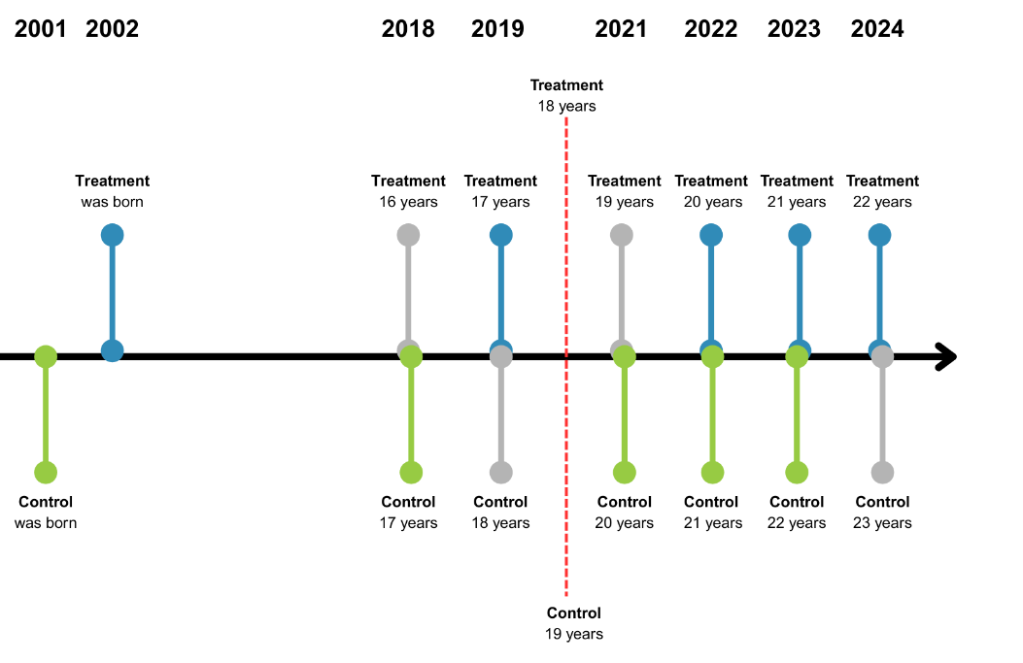
Source: Author’s work.
One can think of the teenagers from both cohorts as comparable at the same age, as most of their life conditions are unlikely to change significantly over a one-year difference. However, they are not comparable in the same year, because the older cohort has an advantage of either one additional year of education or one additional year of work experience, which impacts their labor market outcomes. Considering the first case, both cohorts would have experienced similar labor market paths had the pandemic not occurred, enabling the designation of the younger cohort as the treatment group and the older cohort as the comparison group. A balance check analysis is performed and presented in the results section, providing evidence of the resemblance between both cohorts.
In this context, after 2020, the only distinction between the two groups is the differential education the younger cohort received due to lockdowns. Hence, a classic 2x2 DiD model was set up comparing the outcomes when the cohorts were 17 years old against when the cohorts were 20 years old, as described in equation (1):
$$y_{it}=β_{0}+β_{1}{Treatment}_{i}+β_{2}{Post}_{t}+β_{3}{Treatment}_{i}{Post}_{t}+e_{it}$$ | (1)
Where $y_{it}$ represents the labor market outcome analyzed, such as income, weekly hours worked, or whether the person is occupied; $β_{1}$ captures all the structural differences between the two cohorts; $β_{2}$ captures the changes in outcomes across time between the pre- and post-periods; $e_{it}$ represents the idiosyncratic error term; and $β_{3}$ is the parameter of interest that quantifies the average treatment effect on the treated (ATT).
This specification satisfies the SUTVA assumption, given that the treatment was received only by the young cohort, and there is no way a person from the control group could be impacted by it directly or indirectly. Someone might argue that the control group could have continued studying in tertiary education during the pandemic, making them also subject to a loss of human capital. Nevertheless, this is not a concern since the returns of one year of High School education differ from the returns to one year of college education. In that sense, the members of the control group who went to college received a different treatment from the one being studied in this paper, and it is not the objective of this study to analyze those effects. Therefore, the potential outcomes of the control group remain valid counterfactuals for estimating the impact of the pandemic on high school students.
The NA assumption is also satisfied since the arrival of the pandemic was an unforeseen event that occurred after the control group had already completed High school and, more importantly, after the treatment group had started classes, so no one was able to change their schooling decisions in response to COVID-19. Additionally, the data for income was corrected for inflation using the Consumer Price Index (CPI) variation of each year, to avoid bias in the estimator. In the same spirit, equation (1) was expanded to include time-invariant qualitative controls into the regression, to remove the effect that those characteristics have on labor market outcomes from the $β_{3}$ coefficient, as presented in equation (2):
$$y_{it}=β_{0}+β_{1}{Treatment}_{i}+β_{2}{Post}_{t}+β_{3}{Treatment}_{i}{Post}_{t}+X_{i}θ_{i}+ e_{it}$$ | (2)
The controls in $X_{i}$ included dummy variables for women, urban areas, and indigenous persons. It was decided not to include the dummy for informal workers with the controls, since this characteristic is time-varying and plausible endogenous to the treatment, potentially biasing the causal estimator. Such endogeneity arises because, during the pandemic, many people might have moved from the formal to the informal sector.
Under equation (2), the interpretation of $β_{3}$ must be more cautious, since it is no longer a direct ATT, but a weighted average of the treatment effect of all subgroups generated by the controls included (Caetano & Callaway, 2024). To simplify interpretation, a homogeneous treatment effect across all groups is initially assumed. This assumption is then relaxed, and a model allowing heterogeneous effects between the demographic groups, as presented in equation (3):
$$y_{it}=β_{0}+β_{1}*{Treatment}_{i}+β_{2}{Post}_{t}+β_{3}{Treatment}_{i}{Post}_{t}+$$  $$β_{4}{Treatment}_{i}{Post}_{t}{Urban}_{i}+ β_{5}{Treatment}_{i}{Post}_{t}{Women}_{i}+$$  $$β_{6}{Treatment}_{i}{Post}_{t}{Indigenous}_{i}+X_{i}θ_{i}+ e_{it}$$ | (3)
Finally, an age-based event study is performed to identify the persistence of the impact over time by expanding the sample to consider multiple years in the future and allowing one coefficient for each of them, as presented in equation (4):
$$y_{it}=β_{0}+β_{1}{Treatment}_{i}+β_{2}{age}_{t}+β_{k}\sum{{Treatment}_{i}{age}_{t}}+X_{i}θ_{i}+ e_{it}$$ | (4)
It is worth pointing out that each equation was estimated using Weighted-Least-Squares (WLS), considering the expansion factor that INE provides for each observation, with the intention of generalizing the results to the entire population of individuals born in 2002 and who were in their last year of High School during 2020. In addition, the reported standard errors are robust to heteroskedasticity, as recommended by Mackinnon and White (1985), confidence intervals and Minimum Detectable Effects (MDE) are also computed to aid in the interpretation of statistically insignificant coefficients.

- Results and Discussion
The first step in the analysis was to identify whether the PT assumption holds. Since the household survey data provided by INE were not panels following the same individuals over time, a dynamic analysis could not be performed. Instead, a balance check was conducted to assess the comparability of treatment and control groups in the pre-period. This is presented in Table 3, where it can be seen that both cohorts show similar demographic characteristics (e.g., the proportion of women and people living in urban areas) and labor market characteristics (e.g., activity, occupation, and informality rates).
Applying Baker et al.’s (2025) rule to analyze the SMD, most variables are below the 0.25 threshold, providing strong evidence that the groups are balanced. The only exception is the indigenous variable for the weighted case, which can be attributed to a change in the weighting factors assigned by INE over the two years of the surveys, rather than a change in the proportion of the indigenous population surveyed, as the unweighted case obtained an estimate of 0.196. Since the gap between the SMD calculated (0.259) and the threshold is not substantial, and the sample was not built specifically for the study, it is going to be considered acceptable for this research.
Table 3. Balance Check between Treatment and Control groups in the Pre-Period
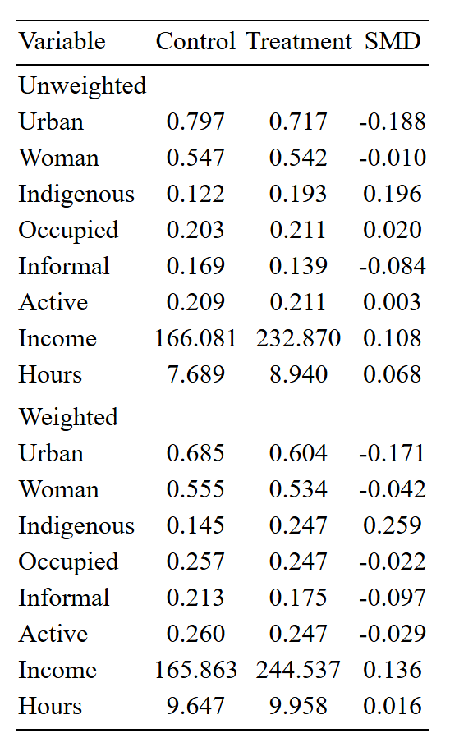
Source: Author’s calculations, using data from the National Employment and Income Surveys of 2018 and 2019. The upper panel presents a simple mean for the values of all variables in the sample, while the lower panel presents a weighted average considering the expansion factor to obtain population estimates. The third column calculates the Standardized Mean Difference (SMD) between treatment and control groups. Urban, Woman, Indigenous, Occupied, Informal, and Active are dummy variables, having a value of 1 for the individuals who belong to each of those demographic groups. “Income” is calculated in Quetzales per month, and “Hours” represent the weekly hours worked by each individual in the primary occupation. Table created using the Stargazer R package (Hlavac, 2022).

The means of each qualitative variable, with their respective 95% confidence intervals, are plotted in Figure 4, while the kernel probability density function (PDF) for income and weekly hours worked are shown in Figure 5. This visual analysis, together with the calculations above, allows for double-checking that the groups are comparable in the pre-period (PT assumption) and provides evidence of the validity of the DiD specification.

Figure 4. Mean and Confidence Intervals for Qualitative Variables in the Pre-Period
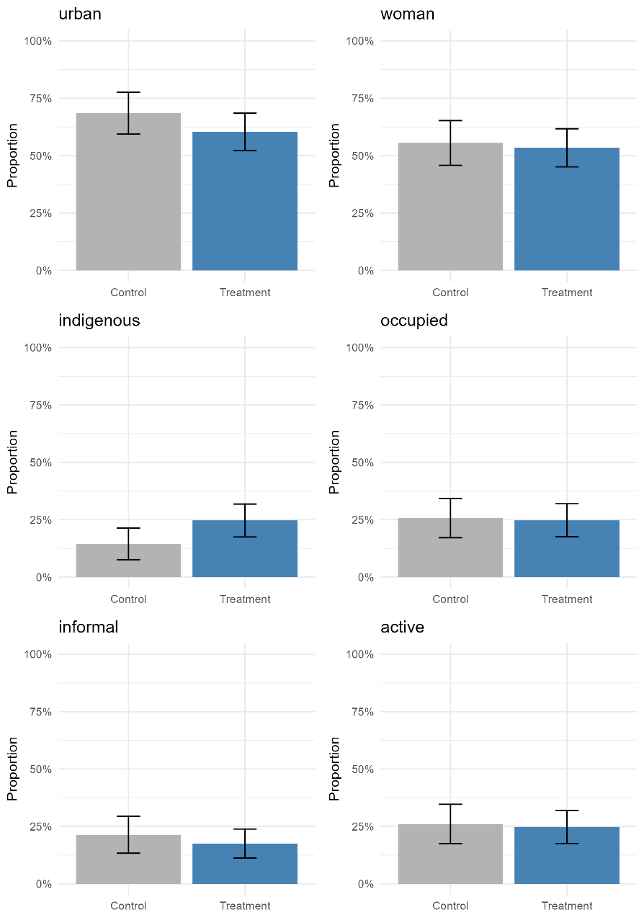
Source: Author’s calculations, using data from the National Employment and Income Surveys of 2018 and 2019. The bars present a weighted average for each variable. Urban, Woman, Indigenous, Occupied, Informal and Active are dummy variables, having a value of 1 for the individuals who belong to each of those demographic groups.

Figure 5. Kernel Probability Density Functions for Quantitative Variables in the Pre-Period
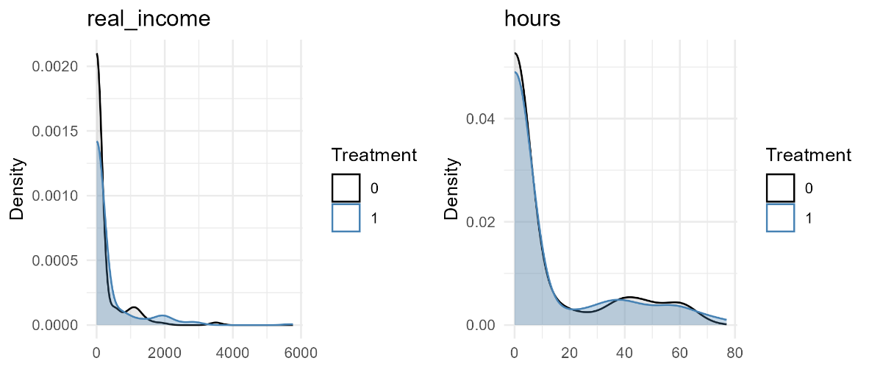
Source: Author’s calculations, using data from the National Employment and Income Surveys of 2018 and 2019. Income is calculated in Quetzales per month, and Hours represent the weekly hours worked by each individual in the primary occupation.

Table 4 presents the results using income as the outcome variable of interest, with each column corresponding to one of the equations derived in the previous section. Models (1) to (3) estimate a negative coefficient $β_{3}$ (treatment x post), although not statistically significant. Additionally, “women” is the only statistically significant control, showing a negative coefficient in both models (2) and (3), which indicates the existence of a gender gap between Q215 and Q230 before the pandemic. These models were able to explain a proportion ranging between 6% and 8% of the variance of income, denoting a limited explanatory power.
Column (3) rules out the possibility of heterogeneous effects, as none of the interactions were significant, while column (4) indicates that by age 22, the treatment group earned, on average, Q279.62 more than the control. This effect is opposite to what was expected and may not be related to the pandemic, since it is unlikely that lockdowns had no effect at first but then suddenly did years later. This column possesses a goodness of fit of 16% and also shows that income increases as cohorts get older, by an average of Q400 each year, which is consistent with intuition.
Looking at the constant term across models, the mean income for the control group before the pandemic was found to be between Q165 and Q376, a very low amount. Recalling Figure 5, where a right-skewed income distribution is presented, and considering that the sample includes both full-time students, who report no income, and individuals who study and work simultaneously, it is plausible that the former are biasing the estimation. The models were therefore re-estimated, including only individuals who reported positive income before the pandemic (about 25% of the sample), with results shown in Table 5.

Table 4. Regression results for income (complete sample)
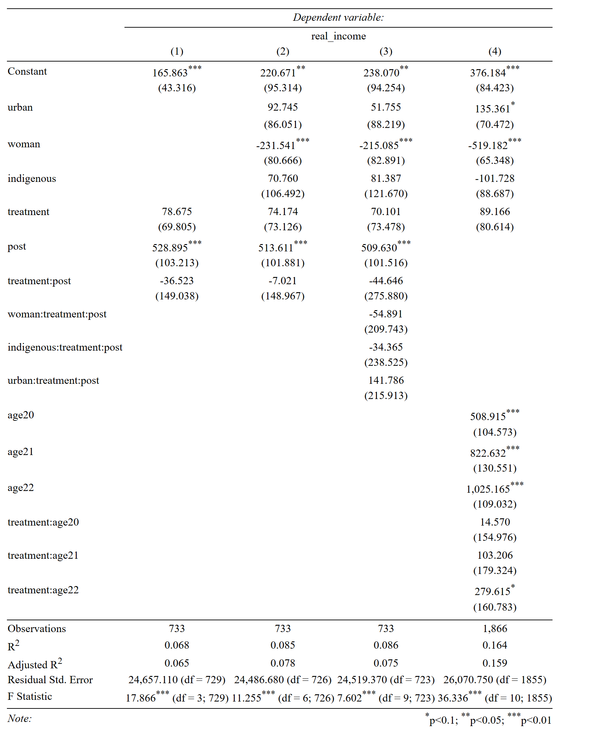
Source: Author’s calculations, using data from the National Employment and Income Surveys of 2018-2024. Table created using the Stargazer R package (Hlavac, 2022).

Table 5. Regression results for income (workers only)
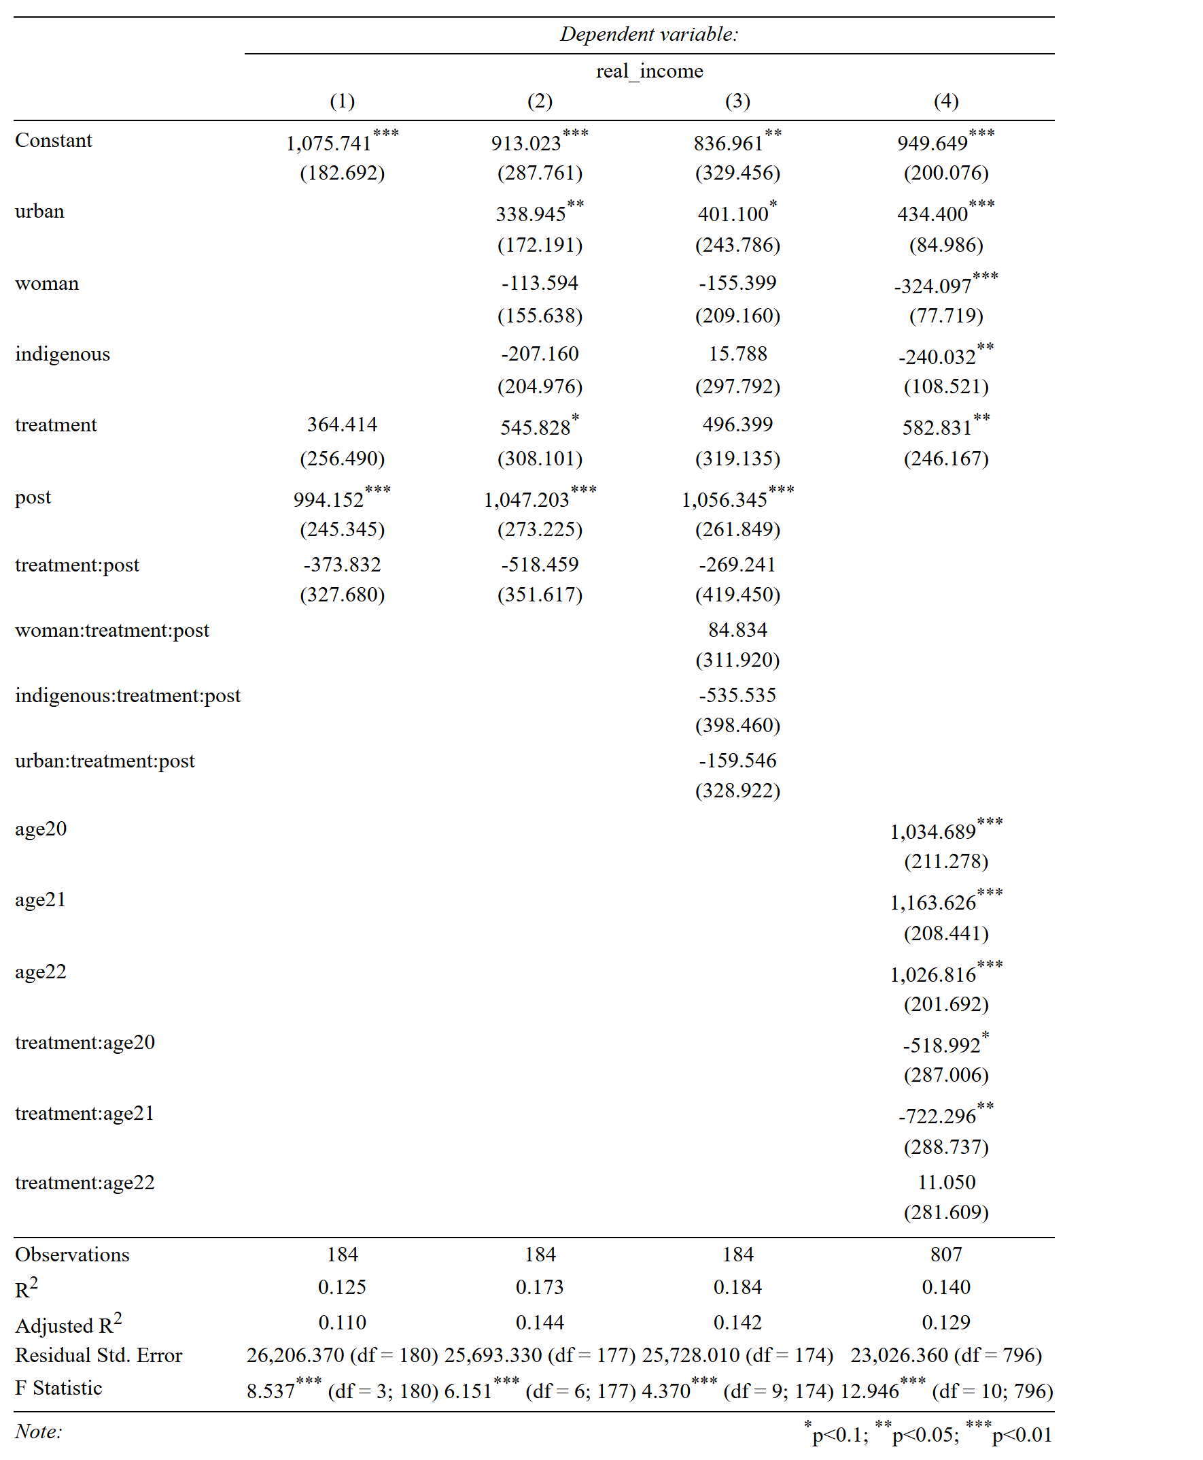
Source: Author’s calculations, using data from the National Employment and Income Surveys of 2018-2024. Table created using the Stargazer R package (Hlavac, 2022).

Under this scenario, the mean income for the control group before the pandemic is around Q1,000, which is closer to the values reported annually by INE. The explanatory power (measured by R-squared) of most models doubles, and the coefficient for urban areas becomes statistically significant, showing that, on average, people living in urban areas earn about Q400 more. In contrast, the coefficient for women remains negative but is not statistically significant, suggesting that the income gap between men and women is not as large once they are employed, although more women than men are outside the labor force.
The $β_{3}$coefficients in columns (1) to (3) remain statistically insignificant, though their magnitudes increase substantially. For example, in the basic specification, the coefficient rises from Q36 to Q373. Finally, the event study shows a significant negative causal impact that persisted for two years after the pandemic ended. Specifically, the treatment cohort earned Q518 less than the control at age 20, and Q722 less at age 21, amounts that represent more than 50% of the baseline income implied by the constant term. It is noteworthy that no significant effect remains for the age of 22, making it necessary to investigate the reasons that allowed an abrupt closure in the gap between cohorts. This model also shows significant evidence that women and indigenous people earn less, indicating that social discrimination translates into economic gaps.
Moving on to the analysis of weekly hours worked, Table 6 presents the results for the complete sample, while Table 7 shows the results only for workers. A significantly negative coefficient is observed for women across models (2) to (4) in the first case, indicating that women work between 7 and 12 hours less than men. However, this difference disappears once the sample is restricted to employed individuals. Taken together, these findings suggest that gender disparities in labor-market outcomes are mainly explained by differences in employment participation rather than by unequal conditions among those who are employed. This pattern could be driven by variables such as social norms, culture, or differences in the jobs taken by men and women.
Additionally, for the complete sample, the indigenous population reports a positive and significant coefficient in all models, a relationship that holds for the constrained analysis in column (3), Table 7. This finding is important, as it indicates that although the indigenous population doesn’t face lower income, the fact that they work more implies their revenue per hour is lower. Further research should aim to understand the reasons explaining this difference, posing hypotheses such as lower productivity or employment in sectors with low value added in comparison to the non-indigenous population.
Table 7 shows that the mean weekly hours worked by the control group before the pandemic were between 40 and 43, which corresponds to a typical full-time schedule. Although no $β_{3}$(treatment x post) coefficient was significant in either sample; the filtered case shows a heterogeneous effect, indicating that there was an impact for women. The event studies did not show any clear conclusion.

Table 6. Regression results for weekly hours worked (complete sample)
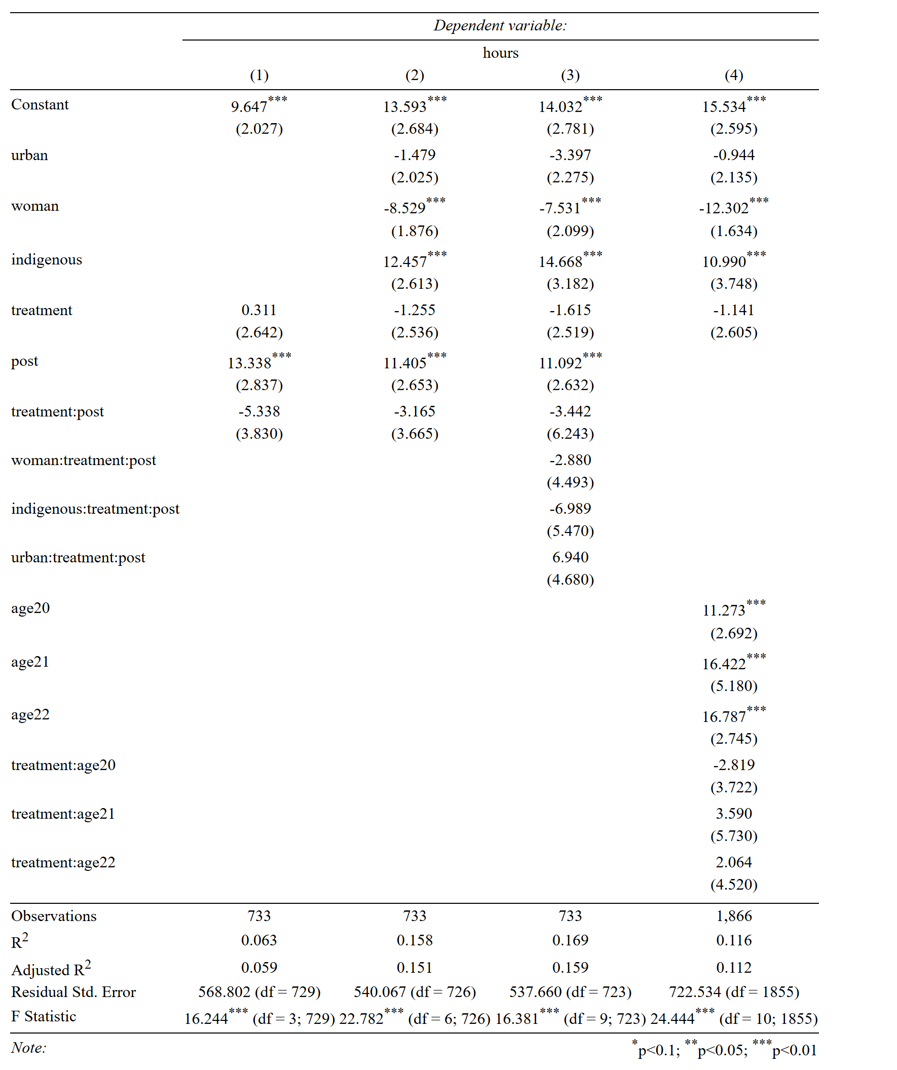
Source: Author’s calculations, using data from the National Employment and Income Surveys of 2018-2024. Table created using the Stargazer R package (Hlavac, 2022).

Table 7. Regression results for weekly hours worked (workers only)
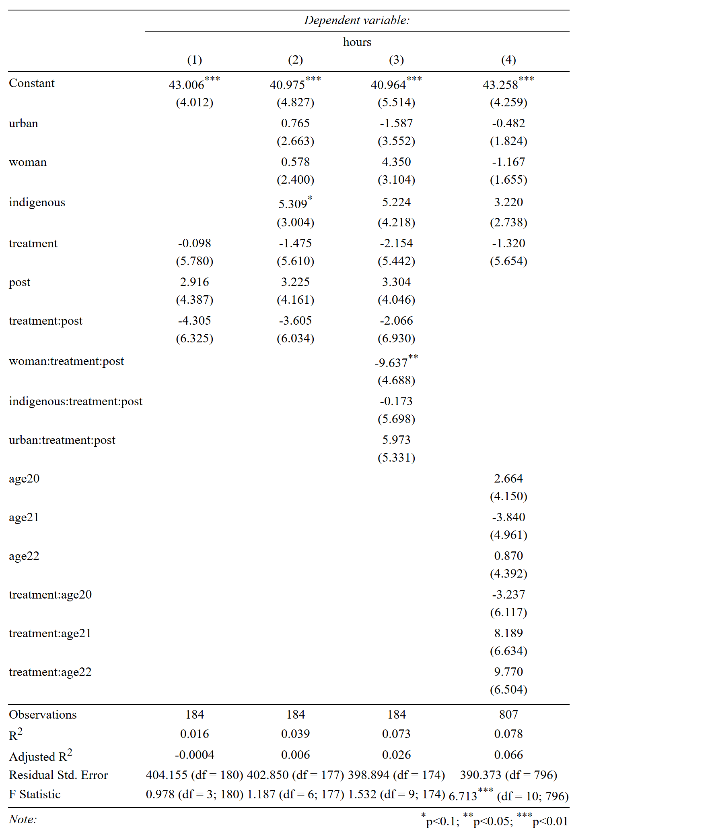
Source: Author’s calculations, using data from the National Employment and Income Surveys of 2018-2024. Table created using the Stargazer R package (Hlavac, 2022).

Continuing to analyze the impact on labor market accessibility rather than on outcomes from working, the estimates are presented with the “occupied” dummy in Table 8. This case presented consistent and significant results in all models calculated. Column (1) shows that the impact for the 2002 cohort was a reduction of 50% in the probability of being employed after the pandemic, a very large estimate. The following two columns show coefficients with the same sign and similar magnitude, providing evidence that the impact is consistent even when controlling for demographic variables and including interactions. Additionally, Column (3) shows that the hypothesis of a homogeneous effect is not valid, since the indigenous population and people living in rural areas faced an even higher impact than the rest.
The goodness of fit for the models in Table 8 is better than for all previously calculated models, reaching a maximum of 38% of variance explained in Column (4). This table shows once more that women structurally have a lower probability of being employed (14–19% lower), which confirms the pattern derived from the analysis of previous outcomes. In contrast, it is interesting that the models find that people in rural areas and the indigenous population have higher chances of being employed (5–10% and 13–27% higher, respectively).
This may seem counterintuitive when considering the whole population of Guatemala, as one would expect more job opportunities in the cities, and that discrimination would reduce the chances of indigenous people finding work. However, the higher probabilities likely reflect structural differences in the types of work available across regions, rather than better economic outcomes for these groups. Furthermore, since this data represents teenagers aged 17 in the pre-period, these coefficients suggest that adolescents in rural areas start working early, which can hinder educational attainment. Thus, challenges are complex; policies need to increase entry-level job opportunities for youth in urban areas while also improving the quality and conditions of work in rural areas.
The event study in Column (4) again shows the negative impact on the probability of being employed after the pandemic for 20-year-olds. However, it also shows that this was a temporary shock, producing higher-than-expected hiring for the treatment group the following year and ultimately leaving a zero net impact in the long run.

Table 8. Regression results for occupied dummy (complete sample)
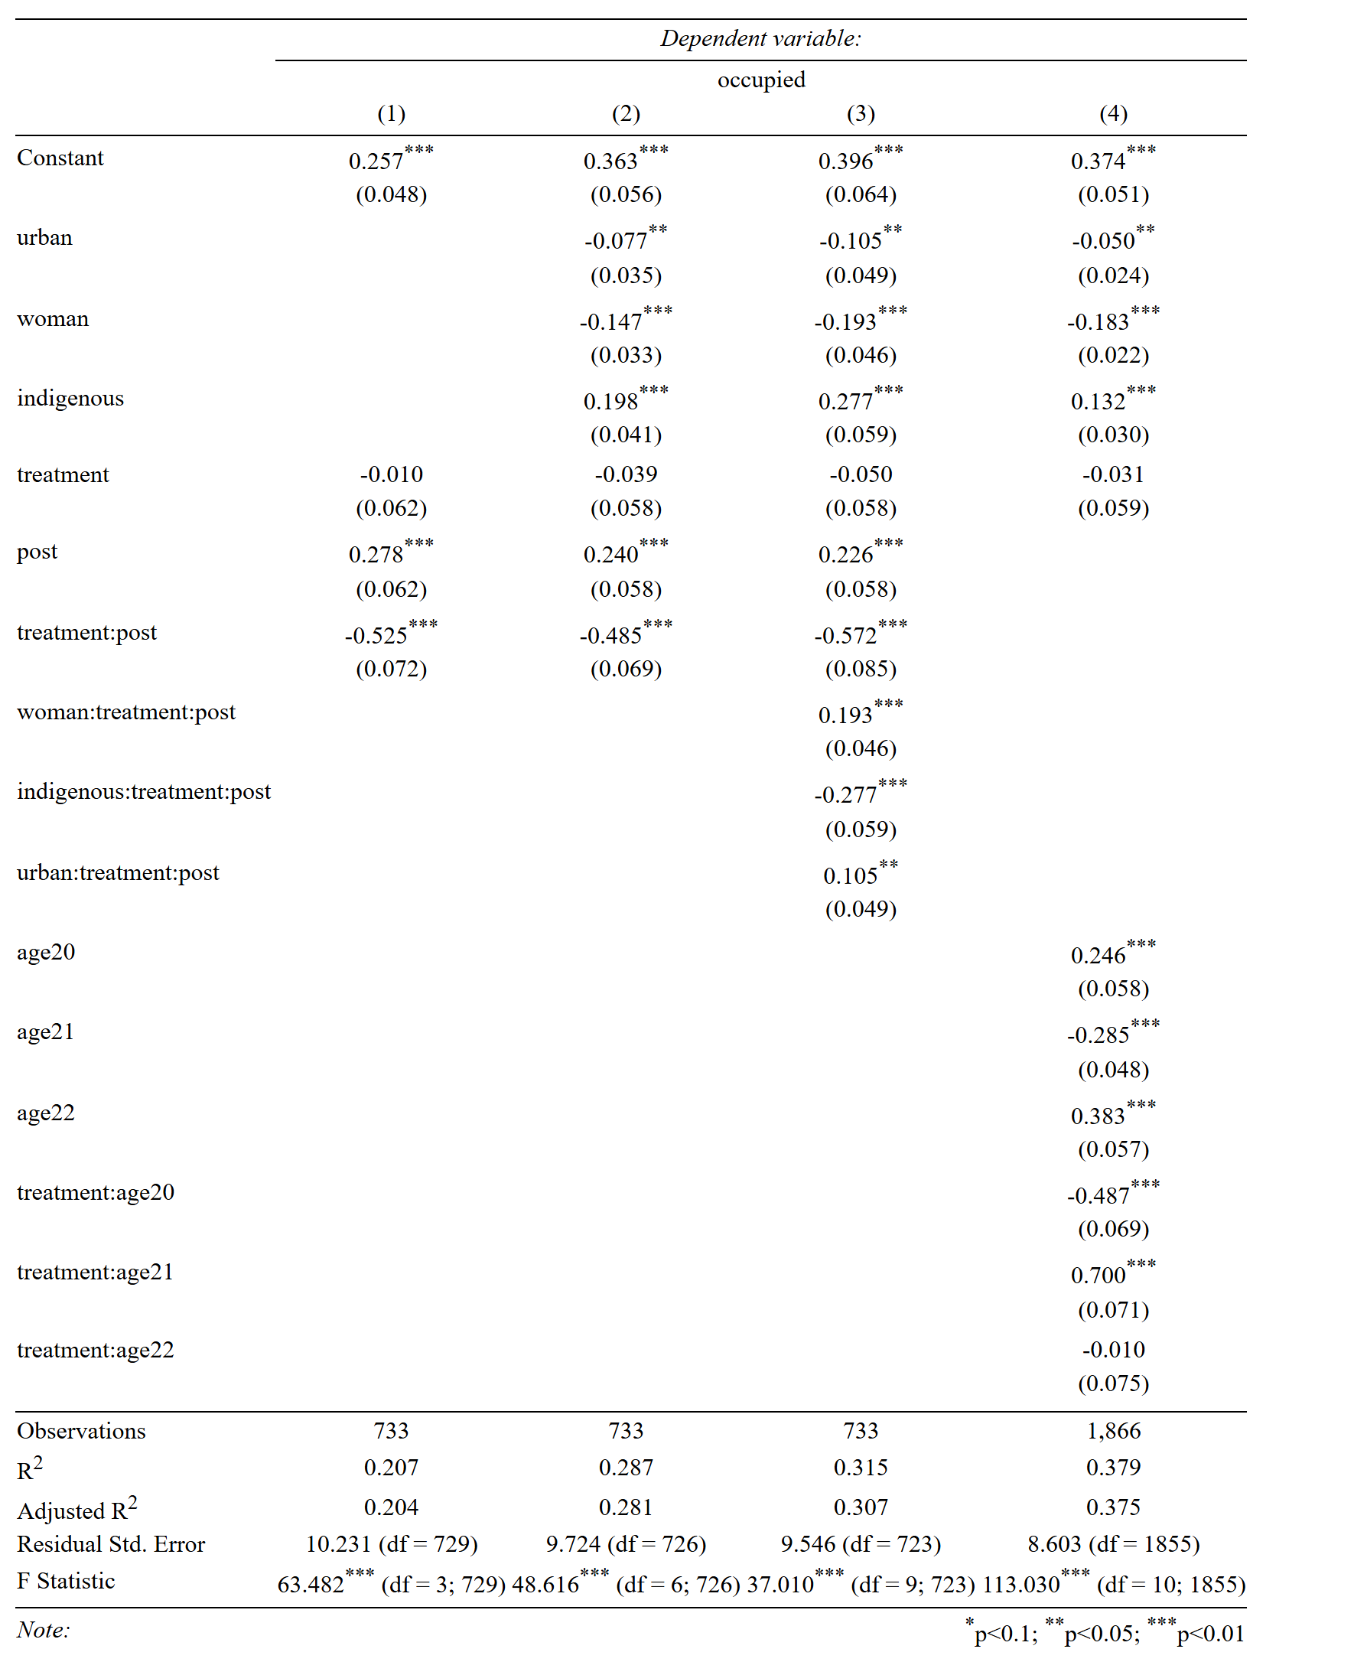
Source: Author’s calculations, using data from the National Employment and Income Surveys of 2018-2024. Table created using the Stargazer R package (Hlavac, 2022).

Summarizing all results found so far, a negative impact on income was detected only in the event study specification, while no effect is statistically significant in any of the conventional DiD models, either for income or weekly hours worked. In contrast, stronger results appear for accessibility to the labor market, consistent with IMF (2020) and Beccaria, Bertranou, and Maurizio (2022), suggesting temporary disruptions in the youth participation on the labor force during the pandemic.
Given this, the hypothesis that in Guatemala the loss of one year of high school does not affect labor outcomes, except for the variable “Occupied”, could be accepted, opening three possible explanations. First, the human capital loss is not relevant for the types of jobs youth actually perform. Many are basic tasks (e.g., growing and collecting crops, assisting in shops or offices, cashiering, serving or waiting for customers, or helping with family businesses, etc.) that do not require abstract skills such as math, professional writing, or science. In this sense, human capital accumulation may matter more in the early years of schooling, while an additional year at higher grades brings little improvement because job opportunities remain limited.
Second, it is possible that no real human capital was lost, given the poor school conditions that undermine education quality. In other words, moving from in-person to distance classes may not have represented much change, since both were of low quality; although, it would be necessary to evaluate the following cohorts to assess whether human capital accumulation was slowed in order to draw long-run conclusions. Finally, though less likely, a more positive explanation is that distance education successfully transferred the same skills to the younger cohort as the older one acquired under normal conditions.
Table 9. Confidence Intervals and Minimum Detectable Effects (MDE)
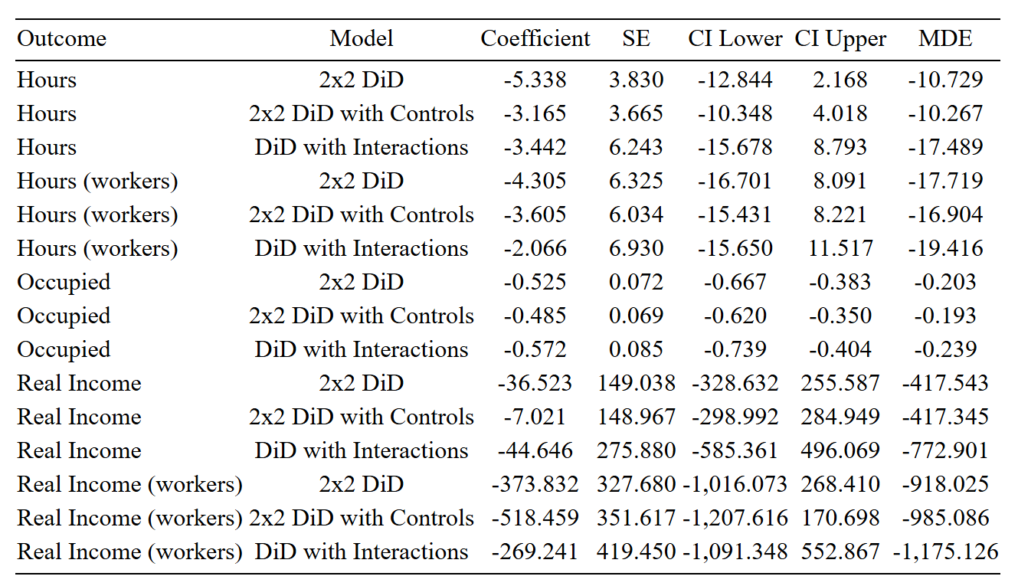
Source: Author’s calculations. Table created using the Stargazer R package (Hlavac, 2022).
However, before drawing firm conclusions, it is important to note that all estimators across models were negative (Table 9), showcasing a trend that suggests a potential impact that the instruments cannot detect. The limited sample size and the lack of repeated individual observations inflate standard errors, causing that when computing the MDEs, they range from two to sixty times larger than the point estimates, with exception for the “Occupied” dummy. This is strong evidence on the fact that absence of statistically significant results reflects insufficient power to detect effects of this magnitude, rather than confirming the absence of impacts altogether Then, it is double-checked when recalling that the event study specification obtained a statistically significant effect for income, which is explained because the sample size is increased 2.5 times for such cases.

- Conclusions
The pandemic was an unforeseen event that severely impacted society, especially because it created a loss of human capital due to the closures of schools during lockdowns. This study identified that human capital loss during 2020 harmed access to the labor market for younger cohorts who graduated after the arrival of COVID-19 in the country, reducing by 50 percentage points the probability that those born in 2002 were occupied when they were 20 years old. Fortunately, this was a temporary impact, with a strong recovery the following year and a diffusion of the effect two years later.
The results indicate that structurally discriminated populations, such as women, indigenous people, and those living in rural areas, experience less favorable labor market conditions. In that sense, efforts are needed to prevent the already existing gaps between the population groups from being exacerbated by this shock or any other in the future. New studies should focus on identifying the variables that explain such differences between groups, specially the proposed: the ethnic heterogeneity in jobs making indigenous population to work in low value-added sectors, or structural differences in productivity.
A two-year persistent impact on earnings was found through an event study estimation, resulting in a reduction in income of more than 50% compared to the pre-pandemic baseline. Furthermore, multiple DiD models showed a negative coefficient on income and weekly hours worked, which, as demonstrated, were statistically insignificant, not because the effect was absent, but because the instruments had too little power to detect an impact of this magnitude. In that sense, further research is recommended to better understand the impact of the pandemic on the labor outcomes of the youth. Collecting primary data through surveys could expand the sample size, and if possible, include geographic information to perform Ham, Vasquez, and Yanez-Pagans’ (2023) identification strategy jointly with the exposed in this paper.
Determining whether there was an impact is important for policy development. If there was an impact, the government should pay attention to professional training programs for the youth, aiming to reinforce their skills and reduce the human capital gap between cohorts that the pandemic created. Moreover, they should not only focus on 2002-borns, but also on all subsequent cohorts whose education was interrupted by the pandemic. These cohorts could be even more affected, as they may have lost more than one year of schooling due to closures persisting through 2021.
On the other hand, if there was no impact, it becomes important to understand the reason, opening up a new research line to be conducted. If it was because of the low-quality education provided to the youth, then the government should focus on improving school conditions, ensuring that every school has adequately trained teachers, and reevaluating whether the curriculum includes the skills that firms are looking for in the youth.
If it was because the return to a high school education is too low, then programs should be developed to foster the growth of new industries across the country, increasing demand for educated workers, raising the returns to education, increasing the interest of people in finishing high school, and creating a vicious circle that reinforces human capital accumulation. Otherwise, failing to support human capital growth would undermine the country’s long-run growth potential, as predicted by the theory and evidence presented in earlier sections of this report.
Additionally, attention should be given to analyzing the closure of the gap between treatment and control cohorts discovered in the event study for the age 22. If it was due to a rapid recovery for the younger individuals, understanding the factors that catalyzed income growth is a key step that could allow the design of policies to replicate the results for the following cohorts. On the contrary, if it was due to a worsening of conditions of the older individuals, then it is showing a possible deterioration of labor market and the urgent necessity to focus on designing policies aimed to strengthen it to satisfy the needs of the youth.
Finally, regarding future statistics generation, it is recommended to official governmental agencies to develop panel microdata registers, as it allows researchers to create more rigorous econometric estimates and guide policymaking.
- References
Arteaga, C. (2018). The effect of human capital on earnings: Evidence from a reform at Colombia's top university. Journal of Public Economics, 157(C), 212–225. https://doi.org/10.1016/j.jpubeco.2017.10.007
Ashenfelter, O., and Krueger, A. (1992). Estimates of the economic return to schooling from a new sample of twins (NBER Working Paper No. 4143). National Bureau of Economic Research. https://www.nber.org/papers/w4143
Baker, A., Callaway, B., Cunningham, S., Goodman-Bacon, A., and Sant’Anna, P. H. C. (2025). Difference-in-differences designs: A practitioner’s guide. arXiv. https://doi.org/10.48550/arXiv.2503.13323
BANGUAT. (2025). Estadísticas macroeconómicas. BANGUAT. https://banguat.gob.gt/page/estadisticas-macroeconomicas
Barro, R. (1991). Economic growth in a cross section of countries. The Quarterly Journal of Economics, 106(2), 407–443. https://www.jstor.org/stable/2937943
Barro, R. J., and Lee, J. (1993). International comparisons of educational attainment (NBER Working Paper No. 4349). National Bureau of Economic Research. https://www.nber.org/papers/w4349
Beccaria, L., Bertranou, F., and Maurizio, R. (2022). COVID-19, empleo e ingresos en América Latina frente a una crisis sin precedentes. Revista Internacional del Trabajo, 161(1), 95–120. https://doi.org/10.1111/ilrs.12200
Becker, G. (1962). Investment in human capital: A theoretical analysis. In Universities-National Bureau Committee for Economic Research (Ed.), Investment in human beings (pp. 9–49). University of Chicago Press. https://www.nber.org/chapters/c13571
Benhabib, J., and Spiegel, M. (1994). The role of human capital in economic development: Evidence from aggregate cross-country data. Journal of Monetary Economics, 34(2), 143–173. https://doi.org/10.1016/0304-3932(94)90047-7
Ben-Porath, Y. (1967). The production of human capital and the life cycle of earnings. Journal of Political Economy, 75(4, Part 1), 352–365. https://www.jstor.org/stable/1828596
Bils, M., and Klenow, P. J. (2000). Does schooling cause growth? American Economic Review, 90(5), 1160–1183. https://doi.org/10.1257/aer.90.5.1160
Chetty, R., Friedman, J., Hilger, N., Schanzenbach, D., Saez, E., and Yagen, D. (2011). How does your kindergarten classroom affect your earnings? Evidence from Project STAR. Quarterly Journal of Economics, 126(4), 1593–1660. https://doi.org/10.1093/qje/qjr041
Duflo, E. (2001). Schooling and labor market consequences of school construction in Indonesia: Evidence from an unusual policy experiment. The American Economic Review, 91(4), 795–813. https://doi.org/10.1257/aer.91.4.795
Duflo, E., Dupas, P., and Kremer, M. (2021). The impact of free secondary education: Experimental evidence from Ghana (NBER Working Paper No. 28937). National Bureau of Economic Research. https://www.nber.org/papers/w28937
ECLAC and ILO (2021). Employment situation in Latin America and the Caribbean (No. 26, June 2021). United Nations. https://www.ilo.org/media/406136/download
FUNDESA (2025). Índice de competitividad local. FUNDESA. https://www.fundesa.org.gt/indices-y-evaluaciones-de-pais/indice-de-competitividad-local
Ham, A., Vazquez, E., and Yanez-Pagans, M. (2023). The effects of differential exposure to COVID-19 on educational outcomes in Guatemala (Policy Research Working Paper No. 10308). World Bank. http://hdl.handle.net/10986/39443
Hlavac, M. (2022). stargazer: Well-Formatted Regression and Summary Statistics Tables. Social Policy Institute, Bratislava, Slovakia. R package version 5.2.3. https://CRAN.R-project.org/package=stargazer.
IMF. (2020). Latin American labor markets during COVID-19. In Regional Economic Outlook: Western Hemisphere, October 2020. https://www.imf.org/-/media/Files/Publications/REO/WHD/2020/Oct/English/Labor.ashx
INE. (2019). Encuesta nacional de empleo e ingresos 2018. INE Guatemala. https://www.ine.gob.gt/encuesta-nacional-de-empleo-e-ingresos/
INE. (2020). Encuesta nacional de empleo e ingresos 2019. INE Guatemala. https://www.ine.gob.gt/encuesta-nacional-de-empleo-e-ingresos/
INE. (2022). Encuesta nacional de empleo e ingresos 2021. INE Guatemala. https://www.ine.gob.gt/encuesta-nacional-de-empleo-e-ingresos/
INE. (2023). Encuesta nacional de empleo e ingresos 2022. INE Guatemala. https://www.ine.gob.gt/encuesta-nacional-de-empleo-e-ingresos/
INE. (2024). Encuesta nacional de condiciones de vida 2013. INE Guatemala. https://www.ine.gob.gt/pobreza-menu/
INE. (2025). Encuesta nacional de empleo e ingresos 2024. INE Guatemala. https://www.ine.gob.gt/encuesta-nacional-de-empleo-e-ingresos/
Krueger, A., and Lindahl, M. (2000). Education for growth: Why and for whom? (NBER Working Paper No. 7591). National Bureau of Economic Research. https://www.nber.org/papers/w7591
Lucas, R. (1988). On the mechanics of economic development. Journal of Monetary Economics, 22(1), 3–42. https://doi.org/10.1016/0304-3932(88)90168-7
MacKinnon, J. G., and White, H. (1985). Some heteroskedasticity consistent covariance matrix estimators with improved finite sample properties. Journal of Econometrics, 29(3), 305–325. https://doi.org/10.1016/0304-4076(85)90158-7
Mankiw, N., Romer, D., and Weil, D. (1992). A contribution to the empirics of economic growth. The Quarterly Journal of Economics, 107(2), 407–437. https://doi.org/10.2307/2118477
Martínez-Martínez, O., Reyes-Martínez, J., Mideros Mora, A., Sánchez Pilco, A., and Rodríguez Salme, C. (2024). Labor markets during COVID-19: Gaps and challenges in Latin America. Frontiers in Sociology, 9, Article 1372404. https://doi.org/10.3389/fsoc.2024.1372404
Mincer, J. (1958). Investment in human capital and personal income distribution. Journal of Political Economy, 66(4), 281–302. https://www.jstor.org/stable/1827422
MINEDUC. (2025). Anuario estadístico educativo. MINEDUC. https://estadistica.mineduc.gob.gt/anuario/home.html
Pritchett, L. (2001). Where has all the education gone? The World Bank Economic Review, 15(3), 367–391. https://doi.org/10.1093/wber/15.3.367
Romer, P. (1990). Endogenous technological change. Journal of Political Economy, 98(5, Part 2), S71–S102. https://www.jstor.org/stable/10.1086/261725
Samaniego, R., Jedwab, R., Romer, P., and Islam, A. (2022). Scars of pandemics from lost schooling and experience: Aggregate implications and gender differences through the lens of COVID-19 (Policy Research Working Paper No. 9932). World Bank. http://hdl.handle.net/10986/36972
World Bank. (2021). Acting now to protect the human capital of our children: The costs of and response to COVID-19 pandemic’s impact on the education sector in Latin America and the Caribbean. World Bank. https://hdl.handle.net/10986/35276
World Food Program (2022). Rebuilding human capital amidst the pandemic: A global analysis of the impacts of COVID-19 on school-aged children and youth. https://www.wfp.org/publications/rebuilding-human-capital-amidst-pandemic-global-analysis-impacts-covid-19-school-aged
Zaman, M. (2012). Human capital and economic growth: An empirical investigation using panel data. IOSR Journal of Humanities and Social Science, 4(6), 43–56.

Municipal GDP per capita is calculated by FUNDESA with its own methodology; it does not correspond to official government statistics.
Curiously, this is similar to the estimate presented in Table 1.
National Life Conditions Survey (ENCOVI) for 2023 and National Employment and Income Survey (ENEI) for the others.
Income was defined as the sum of wages, overtime compensation, commissions, travel allowances, and bonuses earned from the primary occupation.
Stable Unit Treatment Value Assumption
No Anticipation Assumption
Parallel Trends assumption

